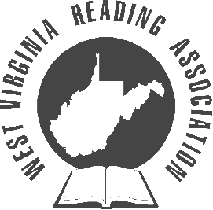
District I
Serving the counties of Brooke, Hancock, Marshall, Ohio, Pleasants, Ritchie, Tyler, Wetzel, Wirt, & Wood.
Volume I, Issue II
February 12, 2008
IRA Honor Council
This is an urgent notice from the WVRA. Please be advised that IRA Honor Council forms are due March 1, 2008. Please take the time to fill out these forms and mail them in as soon as possible. If you run into any difficulties please contact Pat Myers immediately. This has been a public service announcement from the WVRA. Thank you! ☺

Reading In The Mountains
The 53rd Conference of the West Virginia Reading Association will be held on November 13-15, 2008 at the Charleston Civic Center. Mary Kay Wensyel is now accepting program proposals. Proposals are due no later than May 31, 2008. I know there are a wealth of great ideas in District I. Please submit a proposal today and share your great ideas. If you hurry you can have the honor of being the first submission.

Dates to Remember:
IRA Honor Council Deadline March 1, 2008
Honor President Forms Due To Joyce Morris April 7, 2008
Local Officer Reports Due To Joyce Morris April 15, 2008
WVRA Executive Board Meeting @ Elkins April 19, 2008
Middle School Saturday Seminar @ Bridgeport April 26, 2008

Melissa Davis, District I Director
District I
District I

